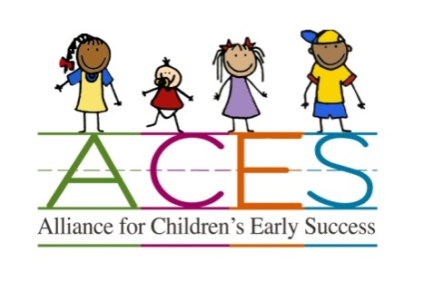
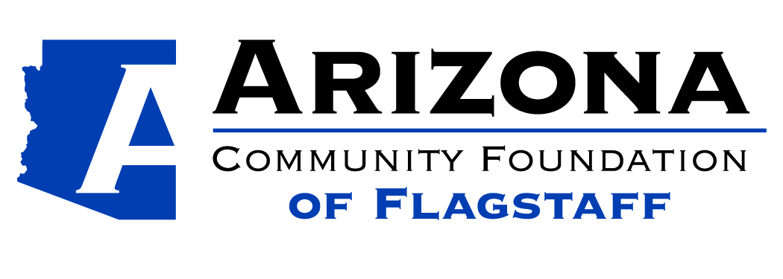

Alliance for Children’s Early Success (ACES)
Quality Improvement Grant Application

Grant Specifications:
- Grant requests up to $1,000.00 will be considered
- MUST be in FUSD geographic boundaries to qualify
- Grants MUST help to maintain or obtain child care certification or licensure and STEAM emphasis.
(STEAM: Science, Technology, Engineering, Arts, & Math)
- Grants MUST identify the certification/licensing requirement and/or Az ADE Early Learning Standard or Infant Toddler Guideline the grant will impact
- Applicants who did not receive funding last year and non-Quality First funded will have priority
- Applications due by DECEMBER 31, 2016
- Assistance if needed. Please contact Paula Stefani pstefani@azccaz.org OR 928-714-1716

Applicant Information:

Program Name: ____________________________________________________________________

Contact Name: _____________________________________________________________________

Street Address (including city and zip code):____________________________________________
___________________________________________

Mailing Address (if different from above): ____________________________________________
____________________________________________

Day Phone Number/s: _________________________________________________________

Email Address: ___________________________________________________________

How did you learn about this grant opportunity?

How will you plan to use the Grant Funds? (Use a separate sheet of paper if needed)

Which certification/licensing requirement or AZ ADE Early Learning Standard or Infant and Toddler Guideline will this grant impact?

How will these purchases improve the quality of your program?

General Information about Your Program
Your Program is currently: (Check all that apply)
___DES Certified Child Care Home (Provide Copy of Certification with Application)
___DHS Certified Child Care Group Home (Provide Copy of License with Application)
___DHS Child Care Center (Provide Copy of License with Application)
___DES Child Care Subsidy Contracted
___Supports Families with limited resources
If yes, please describe what support you provide: ________________________________________________________________________
___ Current participation in a quality improvement grant through: (check all that apply)
  - _____ Arizona Self Study b._____ Quality First c. ____ EMPOWER
  - If no, have you applied for are you interested in learning more?
____Accredited by _____________________ (Provide copy of Accreditation Certificate with Application)

Information about the Children You Serve
- What is the capacity of your child care program? ______________________________
- Average Daily Enrollment: ________________
- What age groups do you serve? ____________
- Number of children with special needs you serve: _______
Describe the special needs: __________________________________________________

Breakdown of Grant Funds Requested

Area of Improvement | Specific Materials/Resources/Trainings Requested | Vendor | Total Cost
 |  | Subtotal:
 |  | Tax if applicable:
 |  | Shipping if applicable:
 |  | Total amount requested:

I agree to submit receipts for quality improvement purchases and provide a summary of how the grant helped to increase quality and a photo by 4/30/17 if I receive a grant.

________________________________________________ _______________________
Signature Date

