January 25th 2017 at the Moenkopi Legacy Inn & Suites
“Tsots-Vahl’Ki”

1ST ANNUAL METHAMPHETAMINE AWARENESS CONFERENCE

Starting promptly @ 9:00 am MST to 4:00 pm MST
A Light Lunch will be served at the Upper Village of Moenkopi’s Community Center.
A Conference fee of $35.00 per person is required to attend the 1-day Conference. All Materials will be included needed for the Conference. The Conference is limited to 50 persons 75 Maximum.
Conference Fees must be received by Friday Jan. 20th 2017 5 PM MST.

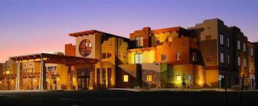
For more information regarding payment for Conference Fee, please contact Jeremy King @ 928-660-3542 or email Jeremy King @ thesession.2017@gmail.com.

