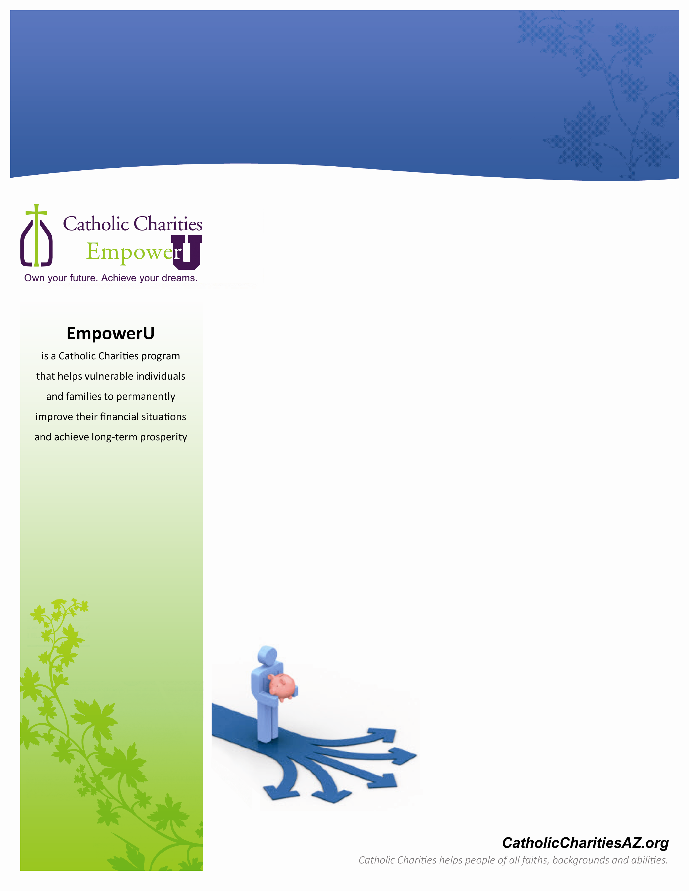

**To register, contact**

**Lauren Randel**

**larandel@cc-az.org**

928-890-4254

**Small change. Brighter future.**

Put more money in your wallet. We’ll help you take control and help you to:

* have money for the things you need
* be ready for the unexpected
* take control of financial choices
* understand when borrowing money will help you

get ahead and when it will hold it you back

Join us and learn how small changes lead to big returns with a free workshop on reducing debt, increasing savings and managing your money.

**September 13th**

**5:30 pm to 8:30 pm**

**Catholic Charities Community Services**

2101 N 4th St

.

***Take charge of your financial future!***