Back-to-School &
Community Health Fair

Saturday, July 16, 2016 from 10:00 a.m. to 1:00 p.m.
Coconino County Public Health Services District
2625 N. King Street, Flagstaff
*Event set-up 9am *Must stay for the entire event
*Please bring your own table, chairs, canopy (with weights)
- Please provide the following information for your organization's representative:
Department/ Program:
Contact Name:
Email Address:
Contact Phone:
- Please provide a short description (2-3 sentences) of your department’s booth activity.
___________________________________________________________________________
___________________________________________________________________________
- This Back to School Fair requires one school supply related give-away available to each child visiting your table for approximately 500 children attending. Some suggestions are: crayons, glue sticks, tissues, colored pencils, binders, loose paper, notebooks, folders, pencils, pens, erasers, pencil case, makers, rulers, protractors, compass, flash drives, hand sanitizer, etc. No candy please.
What school item(s) will you give-away? (We will contact you if your selection is duplicated):_________________________________________________________________
- Special requests (electricity, etc.): ___________________________________________________________________________
Return the attached form to Lucy Walsh at lwalsh@coconino.az.gov or fax 928-679-8771 before June 1, 2016.
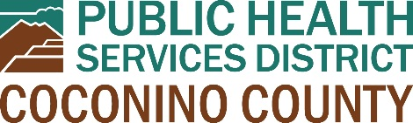
Thank you!

