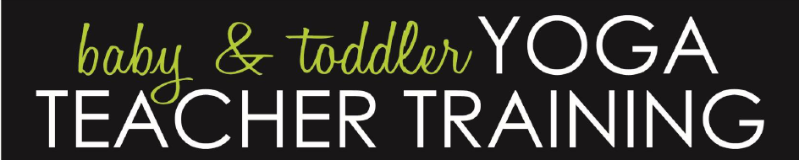

Scholarship Application for the
Child Light Yoga Baby and Toddler Teacher Training
January 30th - January 31st
Coconino Coalition for Children and Youth (CCC&Y) is pleased to present the ChildLight Yoga Baby and Toddler Teacher Training this coming January, 30th and January 31st, 2016.

This training is an opportunity for area professionals to attend and become trained in the ChildLight Yoga Baby and Toddler training, designed to provide participants with the tools and knowledge needed to share the gifts of yoga with children ages birth through 2 years. A limited number of scholarships are available through a Coconino Community Initiative grant from the Coconino County Board of Supervisors. We will determine the scholarship amounts based on the number of applications we receive. If selected, you would not pay more than half the registration fee ($180). The recipients of these scholarships will be selected by CCC&Y’s Alliance for Children’s Early Success (ACES) Committee based on geographic areas and agency representation. Applications are due no later than Tuesday, December 22nd, 2015 and recipients will be notified by December 31st, 2015 of their eligibility.

CCC&Y is leveraging this training for the benefit of the broader Coconino County community. Each scholarship recipient must commit to becoming certified in ChildLight Yoga Baby and Toddler Teacher Training which includes facilitating at least three yoga classes in their community within three months of the teacher training. Additional certification requirements include: developing a lesson plan for each of the three yoga classes, evaluating each class after completion, and taking a short take home exam. You will have the support and assistance of the ChildLight Yoga staff as needed during your certification process.

To be eligible for a scholarship you must commit to completing the certification requirements and to being a continued resource in your community. Prior to the training, scholarship recipients participating are asked to sign and submit a commitment form.
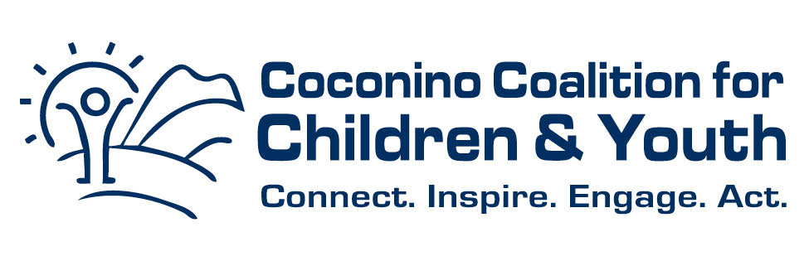

Scholarship Application for the
Child Light Yoga Teacher Training in Coconino County
January 30th - January 31st

Please provide the following information to apply for this scholarship.

Name/Title: _____________________________________________
Agency: ______________________________________________
Address: _____________________________________________
Phone/Fax/Email: _________________________________________
Geographic Area You Plan to Provide Classes: _______________________________________________________

Comments on how training might help you in your efforts to support children and families:

Please return your completed form ASAP to Ruth Ellen Elinski at ruthellen@coconinokids.org
Questions: 928-679-7318

