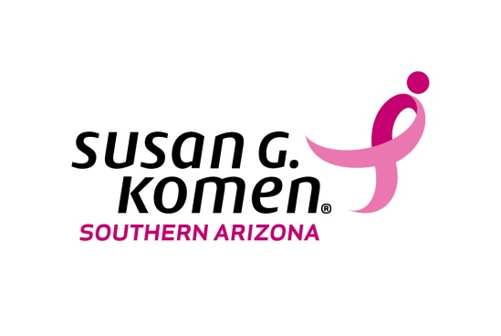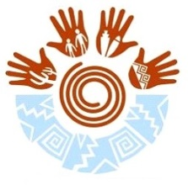

A project of the **Partnership for Native American Cancer Prevention** (NACP) Outreach Program in partnership with the Susan G. Komen Southern Arizona Foundation

Learn how to apply for funds for up to $10,000 to support your NA community projects in health related cancer prevention and control activities.

Hands on training in completing the applications from the Partnership for Native American Cancer Prevention and the Susan G. Komen Southern Arizona Foundation.

Previously funded projects include:

* Educational advertisements for cancer screening
* Community education events and materials development
* Youth tobacco cessation programs
* Cancer survivor support through art and healing

To REGISTER Contact: AMANDA URBINA at [urbina2@email.arizona.edu](mailto:djones1@email.arizona.edu) or 520-621-3281

**FREE** workshop for AZ Tribes and NA communities

## November 3

9:00am- 2:00 pm

4 Locations

* Tucson
* Flagstaff
* Phoenix
* Hopi