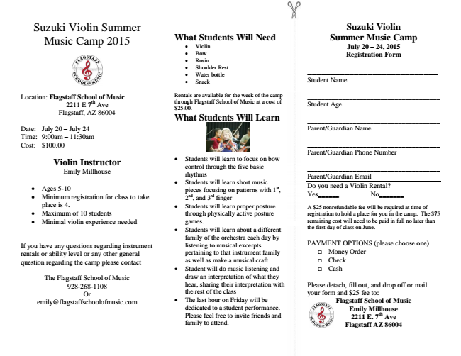

Location: Flagstaff School of Music
2211 E 7th Ave Flagstaff, AZ 86004
Date: July 20 – July 24 Time: 9:00am – 11:30am Cost: $100.00
Violin Instructor Emily Millhouse
• Ages 5-10
• Minimum registration for class to take place is 4.
• Maximum of 10 students
• Minimal violin experience needed
If you have any questions regarding instrument rentals or ability level or any other general question regarding the camp please contact
The Flagstaff School of Music 928-268-1108 Or emily@flagstaffschoolofmusic.com
Suzuki Violin Summer Music Camp 2015
What Students Will Need
• Violin
• Bow
• Rosin
• Shoulder Rest
• Water bottle
• Snack
Rentals are available for the week of the camp through Flagstaff School of Music at a cost of $25.00. What Students Will Learn
• Students will learn to focus on bow control through the five basic rhythms
• Students will learn short music pieces focusing on patterns with 1st, 2nd, and 3rd finger
• Students will learn proper posture through physically active posture games.
• Students will learn about a different family of the orchestra each day by listening to musical excerpts pertaining to that instrument family as well as make a musical craft
• Student will do music listening and draw an interpretation of what they hear, sharing their interpretation with the rest of the class
• The last hour on Friday will be dedicated to a student performance. Please feel free to invite friends and family to attend.
Suzuki Violin Summer Music Camp July 20 – 24, 2015 Registration Form
____________________________ Student Name
______________________________________ Student Age
______________________________________ Parent/Guardian Name
______________________________________ Parent/Guardian Phone Number
______________________________________ Parent/Guardian Email Do you need a Violin Rental? Yes______ No_______
A $25 nonrefundable fee will be required at time of registration to hold a place for you in the camp. The $75 remaining cost will need to be paid in full no later than the first day of class on June.
PAYMENT OPTIONS (please choose one)
□ Money Order
□ Check
□ Cash
Please detach, fill out, and drop off or mail your form and $25 fee to:
Flagstaff School of Music Emily Millhouse 2211 E. 7th Ave Flagstaff AZ 86004

