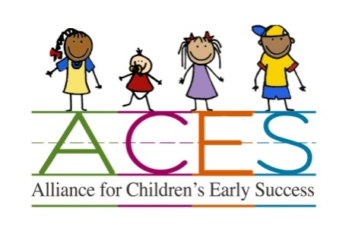

Alliance for Children’s Early Success (ACES)
Quality Improvement Grant Application
and
Access to Quality Child Care Grant Application

Applicant Information: (for both grants)

Program Name: ____________________________________________________________________

Contact Name: _____________________________________________________________________

Street Address (including city and zip code):____________________________________________
___________________________________________

Mailing Address (if different from above): ____________________________________________
____________________________________________

Phone Number/s: _________________________________________________________

Email Address: ___________________________________________________________

What motivated you to participate in this process?

How did you learn about this grant opportunity?

General Information about Your Program
Your Program is Currently (Check all that apply):
___DES Certified Child Care Home (Provide Copy of Certification with Application)
___DHS Certified Child Care Group Home (Provide Copy of License with Application)
___DHS Child Care Center (Provide Copy of License with Application)
___DES Child Care Subsidy Contracted
___Supports Families with limited resources
If yes, please describe what support you provide: _____________________________________________________________________________
___ Currently participating in a quality improvement grant through (check all that apply):
  - ___ Arizona Self Study b.___Quality First
  - If no, have you applied for Quality First? _____ Are you interested in learning more?
____Accredited by _____________________ (Provide copy of Accreditation Certificate with Application)
Information About the Children You Serve
- What is the capacity of your child care program? ______________________________
- Average Daily Enrollment: ________________
- What age groups do you serve? __________
- Number of children with special needs you serve: _______
Describe the special needs: _____________________________________________________
Quality Improvement Grants
- Grant requests up to $700.00 will be considered
- Grants must help to maintain or obtain child care certification or licensure
- Grants must identify the certification/licensing requirement and/or AZ Learning Standard or Infant Toddler Guideline the grant will impact

How do you plan to use the Grant Funds
The following questions may be answered on a separate sheet of paper if additional space is needed.

How do you plan to use the grant funds?
Please provide a breakdown of how the funds requested will be spent. For your convenience there is a blank chart below. You may also submit an invoice of projected expenses.

Which certification/licensing requirement or AZ Early Learning Standard or Infant and Toddler Guideline will this grant impact?

How will these purchases improve the quality of your program?

Breakdown of Grant Funds Requested

Area of Improvement | Specific Materials/Resources/Trainings Requested | Vendor | Total Cost
 |  | Subtotal:
 |  | Tax if applicable:
 |  | Shipping if applicable:
 |  | Total amount requested:

I agree to submit receipts for quality improvement purchases and provide a summary of how the grant helped to increase quality and a photo by 4/30/15 if I receive a grant.

________________________________________________ _______________________
Signature Date

Only applicants within FUSD geographic boundaries are eligible
Applications are due by January 31, 2015
We are here to help! If you need assistance with this application or have any questions, please contact Paula Stefani pstefani@asccaz.org OR 928-714-1716

Access to Quality Child Care Grants
- Grant requests up to $300.00 for an identified family in need will be considered
- Grants are intended to help a family who will have the ongoing means to pay for child care to initially access regulated child care (parent who is just starting a new position, helping a family eligible for the DES subsidy to cover initial registration/co-pay/first week pre-payment of services)
- Ideally, if the family can eventually re-pay the funds to the child care program, that program would apply those funds to a future family. If the family is unable to pay the funds back, the child care program is not out the cost.

Describe the family situation you are applying for a grant up to $300.00 to assist a family to access regulated child care services.

How much of the funds will be used for registration fees? ___________________

How much of the funds will be used for pre-payment of child care services? _______________

If I am chosen to receive an Access to Quality Child Care Grant, I agree to submit receipts and documentation by 4/30/15 of:
- How funds were used
- Follow up story how this assistance helped the family access child care
- Document if the family was eventually able to pay the funds back to assist another family

________________________________________________ _______________________
Signature Date

Only applicants within FUSD geographic boundaries are eligible
Applications are due by January 31, 2015
We are here to help! If you need assistance with this application or have any questions, please contact Paula Stefani pstefani@asccaz.org OR 928-714-1716

