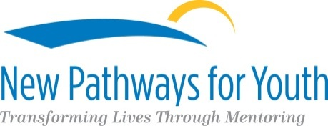

Mentoring Program Coordinator
Position Posting

New Pathways for Youth’s (formerly Greater Phoenix Youth at Risk) mission is to make possible new futures for our children and youth through mentoring and value driven programs. Since 1989, NPFY has served youth experiencing poverty, homelessness and challenging life circumstances. Our programs are research based and focus on building trust in adults, maintaining or improving academic achievement, building better familial relationships, and increasing essential life skills such as decision making and goal setting.
At NPFY, we are transforming lives through mentoring.

FLSA Status: Full time, Exempt

Position Summary: The Program Coordinator has specific responsibility for a mentoring program serving at risk youth, including planning, coordinating and implementing assigned program. The Program Coordinator delivers support and case management services to mentoring matches (mentor and youth) according to best practices and program protocols, ensuring activities meet the specified objectives and outcomes; supervises volunteer mentors for match success; coordinates program logistics; and facilitates evidence based curriculum at one Saturday per month workshops. The Program Coordinator also administers evaluation tools, documents services provided, and reports activities to the Senior Program Manager.

Qualifications
- Minimum of Bachelor’s degree in relevant field of study such as social work, education, or human services and prior experience in positions providing project coordination and case management
- Knowledge of accessing community resources
- Volunteer management and mentoring experience
- Partnership relations and volunteer management experience preferred
- Must be available Monday-Friday from 8:00-4:30 p.m. and the third Saturday of the month; some evenings required
- Minimum of 21 years old and valid AZ driver’s license
- Department of Public Safety Fingerprint Clearance
- Dependable vehicle with proof of current registration and valid insurance
- Eligible to work in the United States of America
- Bilingual (English/Spanish) preferred

To Apply
Send resume and cover letter noting salary requirements to cmcclendon@npfy.org.

