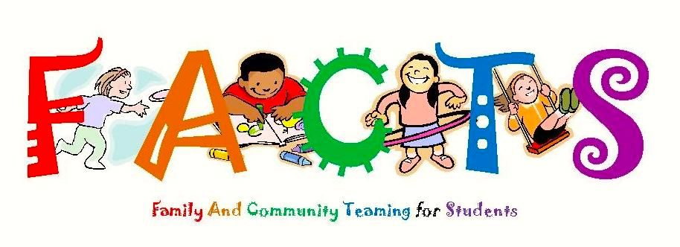
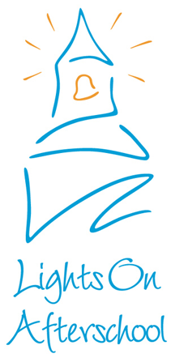
You are invited to participate in the FACTS Afterschool Program’s “Lights On” Carnival. “Lights On” is an annual national event highlighting & celebrating the importance of providing quality programming for our children before school, after school, and other times of the year. Join us for a fun, family carnival and promote how you serve our children and community and rally for support of afterschool programs!

- Saturday, September 12, 2015
- Bushmaster Park
- 10:00-2:00

-Please be set-up by 9:30.
-You must provide your own table.
-You must provide your own shade canopy, if desired.
-According to the City of Flagstaff, nothing can be staked into the ground; tents, signs, etc.
-Also according the city of Flagstaff, all 4 sides of tents or canopies must be properly weighed down, to prevent the tent or canopy from blowing or falling over. This must be done without staking into the ground.
-This is a free event!

--------------------------------------------------------------------------------------------------------------------------------------

_______I would like to participate and will be providing information on my organization and will have an interactive children’s activity.
Activity:______________________________________
Special Requests:____________________________________________________________________

Organization Name:____________________________________________
Contact Name:_________________________________________________
Contact Phone Number:_________________________________________
Contact Email:________________________________________________

Please return to Travis Drake tdrake@fusd1.org 3285 E. Sparrow Ave. Flagstaff, AZ 86004, (P) 527-6168, (F) 527-6190 by Wendy September 10th.

